PowerShell-lab

- Get-Computer info
displays information about computer
- windows version
- computer name
- hardware operating system details

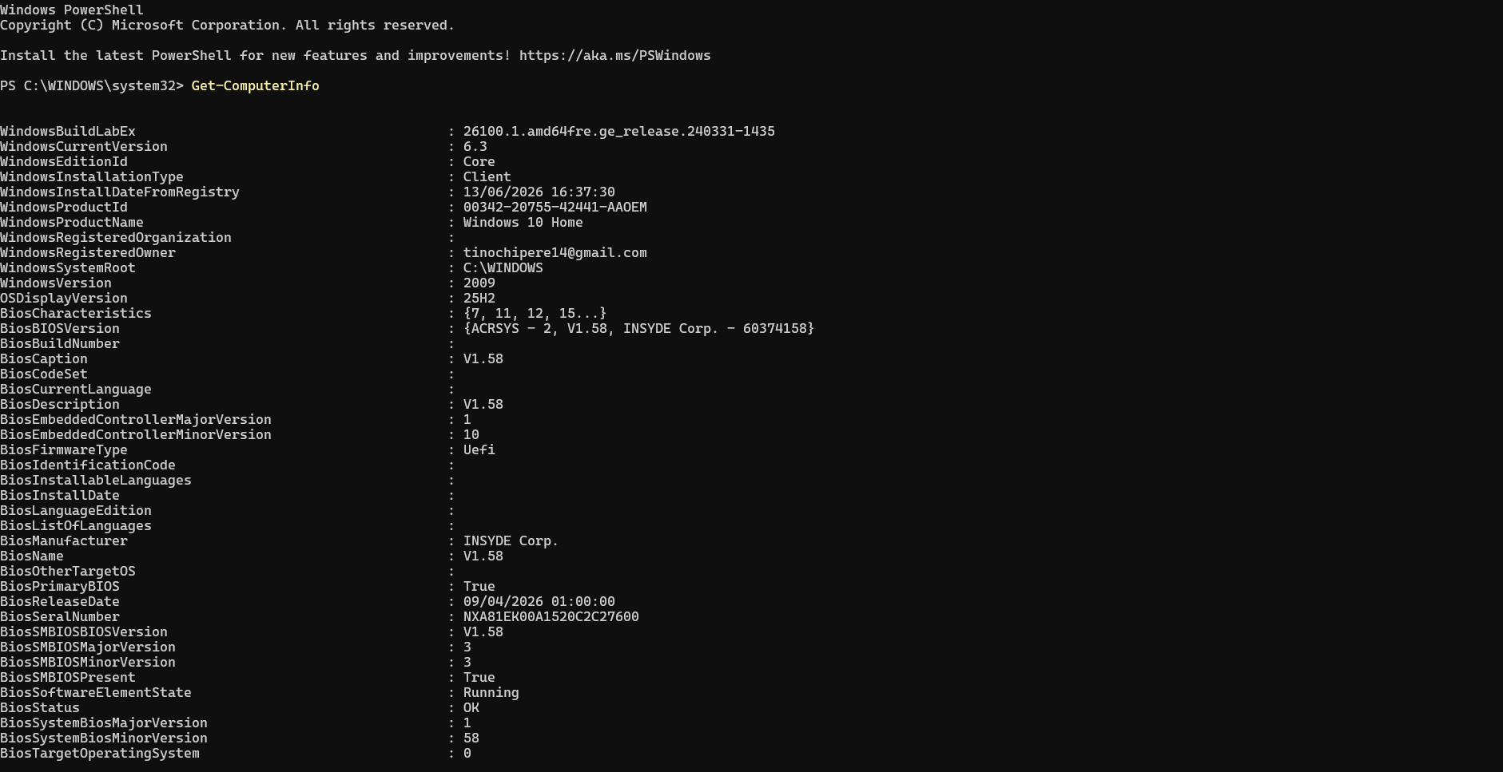
- Get-ComputerInfo | Select-Object CsName, WindowsProductName, WindowsVersion, OsArchitecture, CsTotalPhysicalMemory
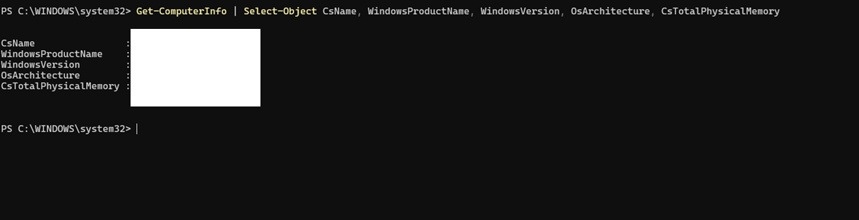
- specfic prompt shorter version

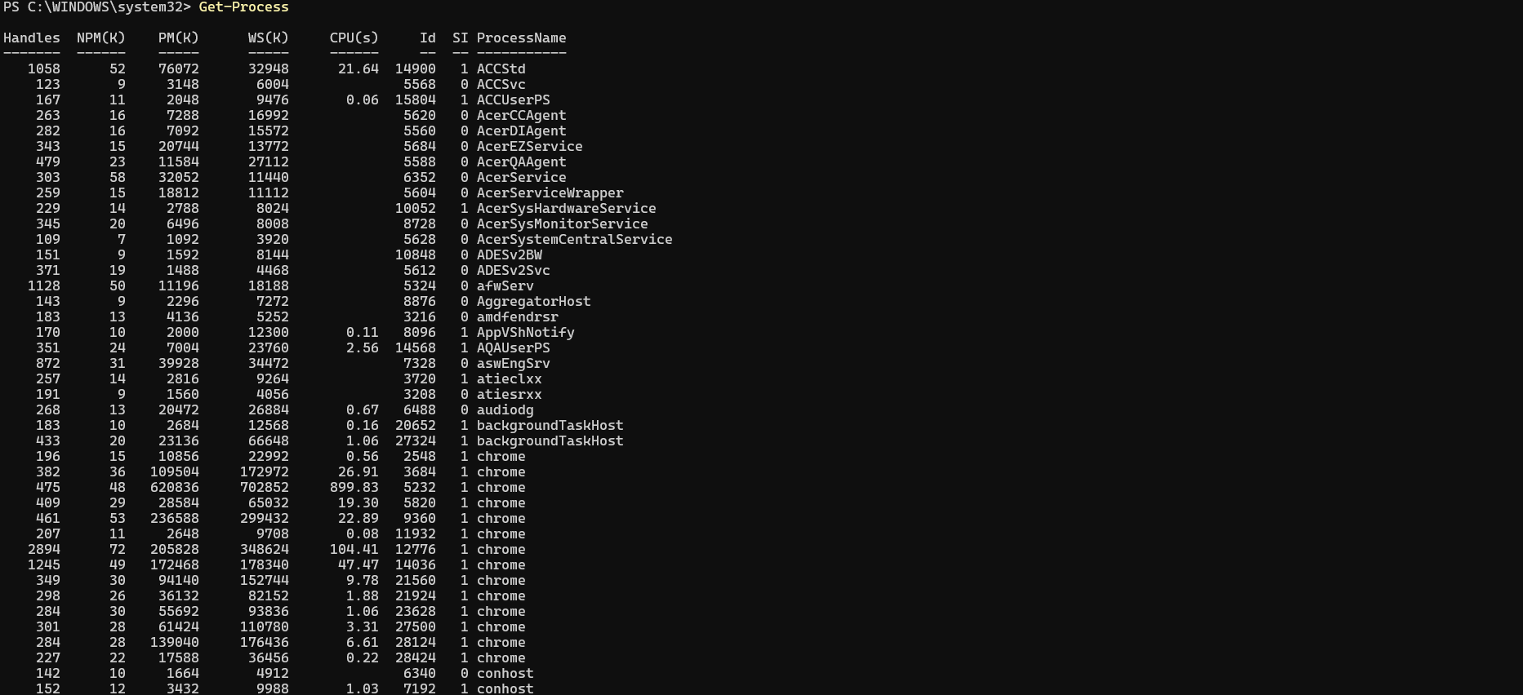
- Get-Process
- shows applications and process running on pc

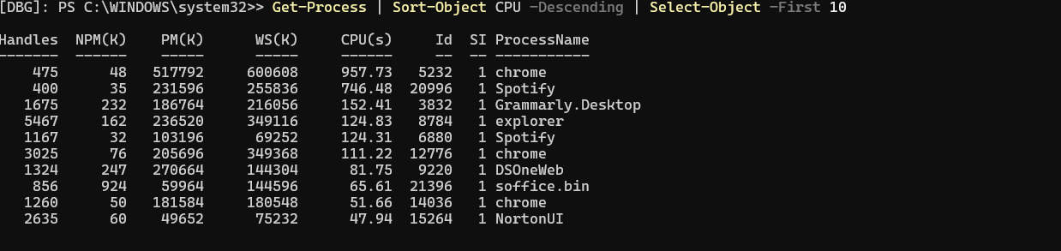
- Get-Process | Sort-Object CPU -Descending | Select-Object -First 10
- processes using up most of the cpu

- Get-Process |Sort-Object WorkingSet64 -Descending |Select-Object -First 10 Name, Id, CPU,@{Name="MemoryMB"; Expression={[math]::Round($_.WorkingSet64 / 1MB, 2)}}
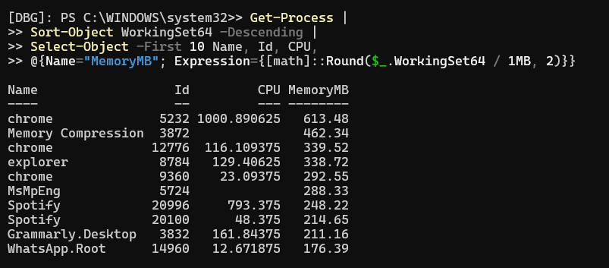
- find the processes using the most memory

- Get-Service
- checks services
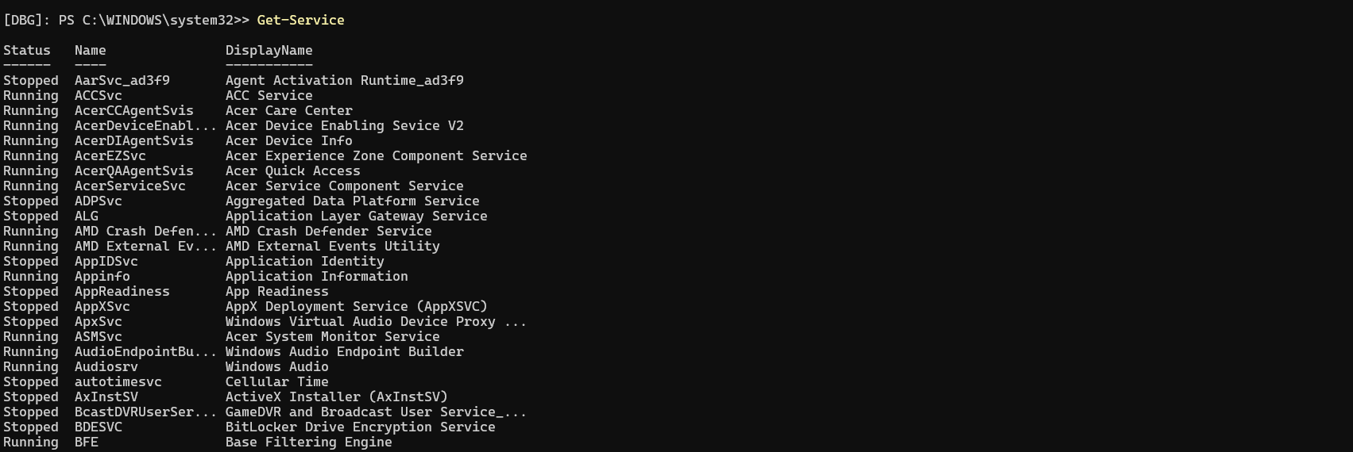
- Get-Service | Where-Object Status -eq "Stopped"
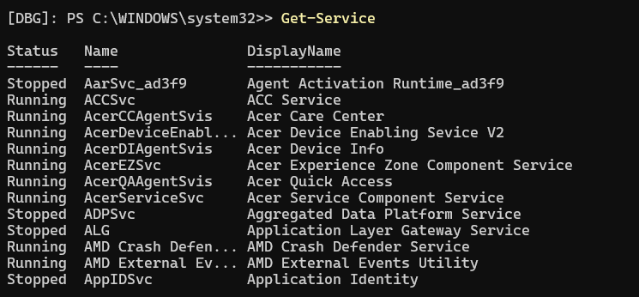
- Get-NetIPAddress
- gives networking information

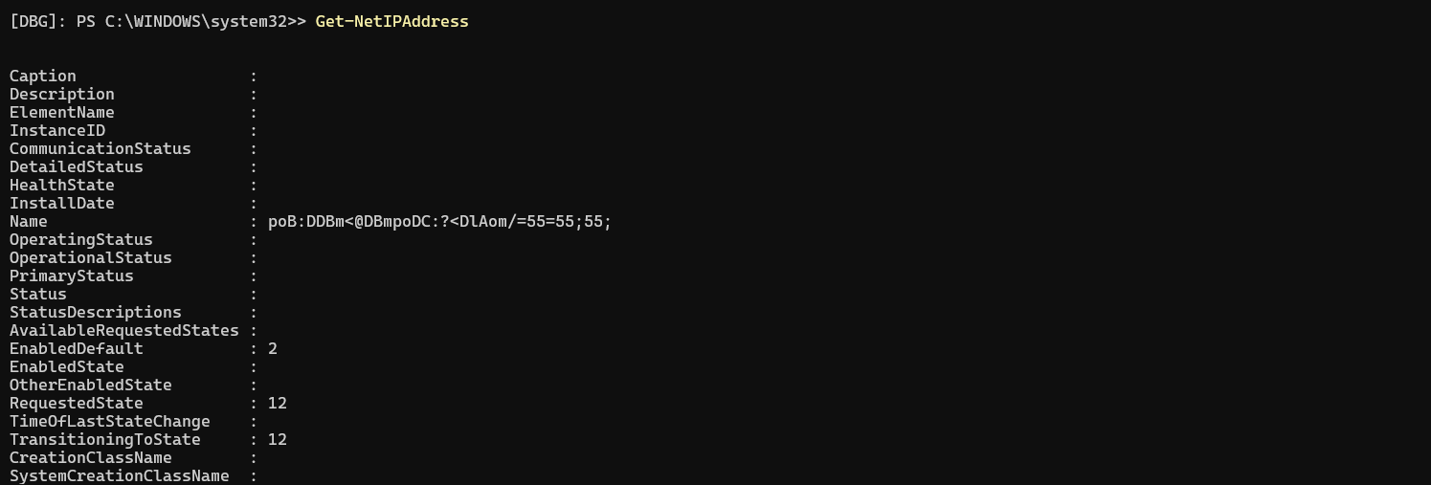

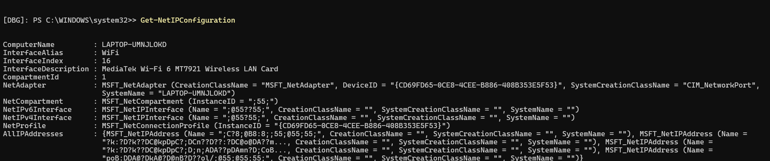

- Test-Connection google.com -Count 4
- test internet connectivity
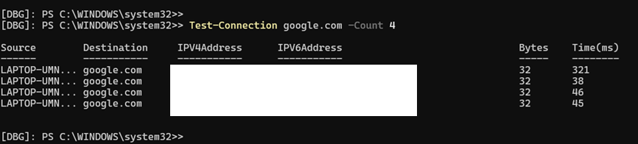
- Resolve-DnsName google.com
- Test DNS resolution
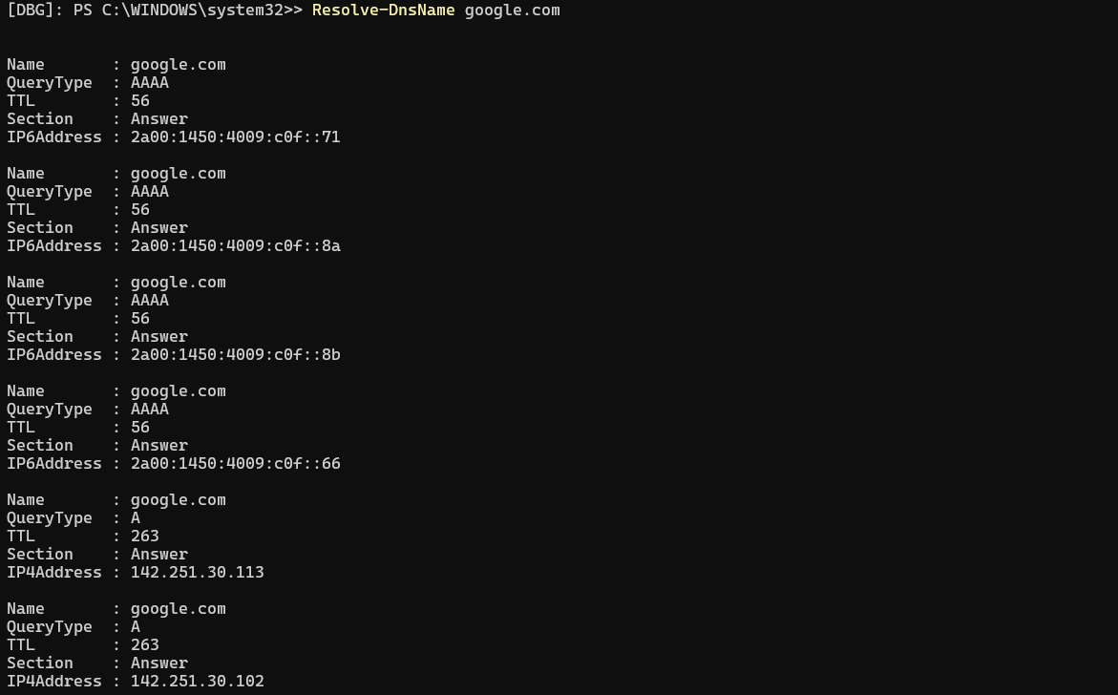

- Get-LocalUser
- Get-LocalGroup
- Get-LocalGroupMember -Group "Administrators"
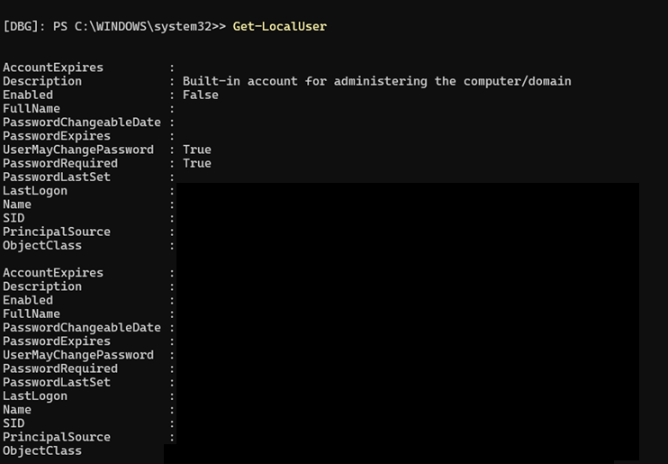
- checking users and groups



